PARENT DECLARATION AND AGREEMENT

It is in your child’s best interest to inform us of the following:

FAMILY DETAILS

Full name of child (this must be the same as their Birth Certificate): | Date of Birth:
 | Birth Certificate Seen:  Office use only. | Birth Certificate Seen:  Office use only
Name known as (If different from above):
Name of parent/s with whom the child lives:  1.  2.  Address: | - Does this parent have parental responsibility? (are they named on the birth certificate) YES/NO  Tel No: ____________Mobile No:_____________  Email:____________________________________  - Does this parent have parental responsibility? (are they named on the birth certificate) YES/NO  Tel No: _____________ Mobile No:_____________  Email:_____________________________________
Name of parent/s with whom the child does not live: | Does this parent have parental responsibility (are they named on the birth certificate)? YES/NO  Does this parent have legal access to the child? YES/NO

CHILD COLLECTION INFORMATION:
Please give details of any person/s with whom your child should not be released to:
Name: |  | Relationship:
Persons who are authorised to collect the child and can collect in case of emergency (must be 16 years of age) ie. relative, childminder or friend:

Name: | Relationship to child
Tel No: | Mobile No:
Address:

Name: | Relationship to child
Tel No: | Mobile No:
Address:

Name: | Relationship to child
Tel No: | Mobile No:
Address: | Signature:  (Of authorised person)
We have a Safeguarding Children Policy (see Parent Pack or Operation Plan for full details) in operation which includes a confidential password system for each child. When a person (ie. your friend, sister or grandparent) is collecting your child and they are unknown to our members of staff, they will only be allowed to leave our premises with your child when the correct password is given.

Please state your chosen password: ...........................................................

Does your child have any special needs or disabilities? YES/NO  If YES please give details: | Are your child’s vaccinations up to date? YES/NO
Has your child ever had a ‘CAF’ or a ‘My Support Plan’, ‘Education, Health and Care Plan’? YES/NO | If YES please give details:
Names of professionals involved with your child
Doctors Surgery: | Dentist Surgery:
Tel No: | Tel No:
Do you have a health visitor? | YES/NO
Name: | Based at:
Tel No:
Does your family have a social worker for any reason? | YES/NO
Name: | Based at:
Tel No:
What is the reason for the involvement of social services with your family?

Does your child have any allergies and if so, to what? YES/NO

Is there any medical information that you feel is important for us to know? Do you have any concerns regarding your child’s speech (YES/NO) or hearing (YES/NO) please circle the appropriate response and provide further details here if necessary:

Does your child need regular medication? YES/NO
If YES please give details:

Does your child use an inhaler(s)? YES/NO  Does your child use a spacer? YES/NO | If YES please state which kind:
PLEASE NOTE: It is the requirement of the EYFS Care Standards that training specific to the individual child
concerned should be provided for staff from a qualified health professional.

PARENTAL CONSENT
Childs Name ..................................................................
Please indicate your consent by circling as appropriate.
Record Keeping  It is our responsibility to keep a record of your child’s experiences and development, whilst they attend the pre-school. These records are available for you to see and discuss at any time. They are also used to inform practitioners at your child’s next setting – YES / NO |  |  | Emergencies  In the unlikely event of an emergency it may be necessary to call an ambulance for emergency treatment or to escort your child to hospital. Every effort will be made to contact you, but we need your consent to call 999 – YES / NO
Plasters  Permission to apply plasters – YES / NO  Photographs  As much of your child’s experiences at pre-school will be practical, it is important to keep photographic and occasionally video evidence. These images will only be used in your child’s pre-school book, and to accompany displays in the pre-school.  Please indicate if you give permission for your child’s photograph to also be used for:  Their Pre-school Records – YES / NO  Pre-school Displays – YES / NO  Newspapers/Publicity – YES / NO  Social Media – YES / NO  Teeth brushing  Please indicate if you are happy for your child to be encouraged to brush their teeth at Pre-school. A tooth brush and toothpaste will be supplied by Pre-school.  YES / NO |  |  | Visits and Outings  We will take the children on visits to the local area (within walking distance) when weather and numbers permit. We may also take the children into the school for some activities. For any other non-local trips we will ask for your written consent at the time – YES / NO
Messy Play/Face Painting
Please indicate whether you are happy for your child to engage in messy play. (paint/cornflour/
jelly etc) and us to use face paints on them from time to time – YES / NO
Seesaw
We will be using the app Seesaw to enable better communication between home and pre-school. This may involve photographs of your child being shared with our parent group. Please indicate if you are happy for this to happen.
YES / NO

Sun Screen
In sunny weather your child’s skin will need protection. We need your consent to apply sun screen and request that you provide a named bottle when appropriate – YES / NO

Parent’s Signature: ................................................................... Date ...........................................................

Child Protection Responsibilities – Statement

Dear Parent/Carer

As a provider of early education registered with Ofsted, I am required to follow the Child Protection Procedures, agreed with the Local Safeguarding Children Board and Ofsted within my responsibility to safeguard children.

As a provider of early education involved in the education of your child, I will endeavour to share with you any concerns I may have regarding injury or specific issues of concern at all times. A confidential record of such incidents will be kept and shared with you.

I do have a duty to refer to Social Services if I suspect your child is at risk of child abuse. I will inform you if I make a referral to Social Services, unless this would place your child at increased risk of significant harm. My first concern will always be the welfare of your child.

I have a copy of the Wiltshire Child Protection Procedures and Guidance for you to see if you wish.

Yours faithfully

Julie Langlands, Manager, Lavington Pre-school

I ___________________________________ (name of person with parental responsibility) have read and understood the above statement and agree with the procedures outlined to ‘Safeguard’ my child.

Signature of person with parental responsibility: ______________________________________

Date: ______________________________

Consent for liaison with outside agencies and Devizes Children’s Centre

Every child has the right to have their individual needs met. In order to do this, it
may sometimes be necessary for us to talk to and share information with
outside agencies or other settings attended.

Wherever possible, we will always discuss with you in the first instance, any
information that needs to be shared.

Whilst your child is attending Lavington Pre-school staff will be monitoring and assessing your child’s progress.

External agencies are welcome to visit our setting.

Declaration

I do give my permission for Julie Langlands, The Manager of Lavington Pre-school,
to discuss my child with outside agencies.

Please state any agencies that you do not wish us to discuss your child

with……………………………………………………………………………………..

I understand that by contacting other agencies the setting is working in
partnership with me as parent/guardian/carer to meet the needs of

(Child’s name) ……………………………. (Date of birth) ……………………....

Signature of parent/guardian with parental responsibility

………………………………………………………………………………………….

Print name ………………………………….. Date ……………………………….

Wiltshire’s local safeguarding children procedures
As a provider involved in the care of your child, we will try at all times to share any concerns we may have. However, in the event that we feel a child has beenharmed or is at risk of significant harm, then we have a duty to follow the Wiltshire Safeguarding Children Board procedures, as set out at http://wiltshirescb.org.uk/wp-content/uploads/2016/10/WSCB_WhatToDoIfYouAreWorried.pdf. Our first concern will always be the welfare of your child.
Operation Encompass: At Lavington Pre-school we are part of Operation Encompass, a police and education early information sharing partnership enabling schools and pre-schools to offer immediate support for children and young people experiencing domestic abuse. Information is shared by the police with the pre-school's Designated Safeguarding Lead (DSL) prior to the start of the next day after officers have attended a domestic abuse incident thus enabling appropriate support to be given, dependent upon the needs and wishes of the child.

ATTENDANCE INFORMATION:
Preferred Starting Date:

Preferred attendance (Please tick the sessions you would like your child to attend each week):
 | Monday | Tuesday | Wednesday | Thursday | Friday
Morning session
9:00 am-12:00 pm
3 Hrs
Morning session
9:00 am-1:00 pm
4 Hrs (including lunch)
Afternoon session
12:00 pm-3:00 pm
3 Hrs (including lunch)
Afternoon session
12:30 pm-3:00 pm
2½ Hrs (including lunch)
Wrap-around Care
8.30 – 9.00am
30 minutes
Wrap-around Care
8.45 – 9.00am
15 minutes
Wrap-around Care
3.00- 3.10pm
10 minutes
If your child will be attending over the lunch time session then you will need provide a packed lunch from home.
Please provide the name of any other pre-school/childminder your child attends:

We are open to accept 2 year old and 3/4 year old Early Years Funding from 9:00 am to 3.00 pm, Monday to Friday which comes to a total of 30 hours a week for 38 weeks per year.
We also offer wrap-around care to align with the opening hours at Dauntsey’s Academy Primary School. This is a payable service for which we are unable to accept Early Years Funding.

PRESCHOOL UNIFORM (OPTIONAL)
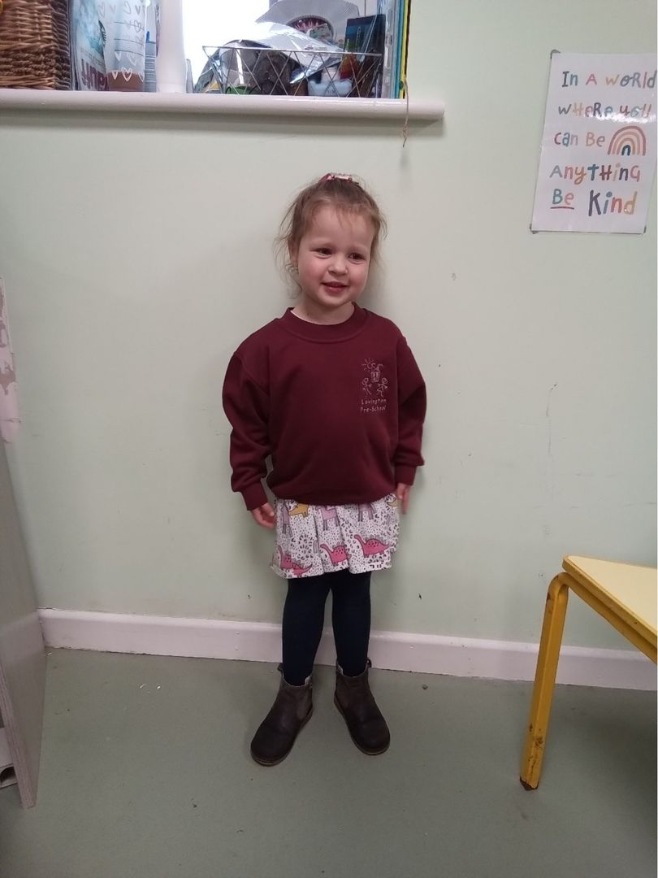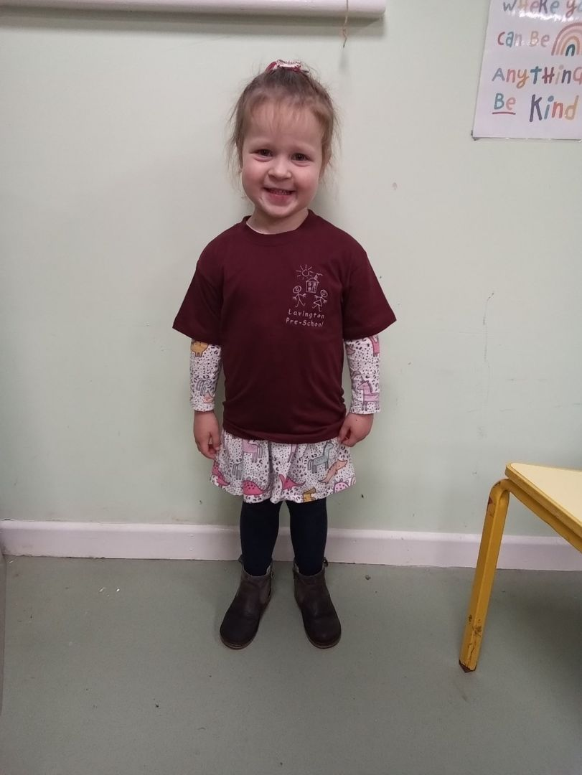

If you would like to order uniform please can you complete the order form below and make payment in advance to allow your order to be processed: T-Shirts - £6.50, Sweatshirts - £10.50
Uniform | Size | Quantity
T-shirt | Age 2
T-shirt | Age 3-4
T-shirt | Age 5-6
Sweatshirt | Age 2
Sweatshirt | Age 3-4
Sweatshirt | Age 5-6

HOT LUNCHES
We are able to offer hot dinners, which are prepared on site at Dauntsey Academy Primary School. Lataca are the company who provide this service. If you would like your child to have hot lunches, please state below, I will email you the details from Lataca which you will have to complete and send to Lataca and you will also have to give Lataca permission to share your child’s details with Dauntsey Academy Primary School. Lataca will contact you with a menu, how to order and how to pay.
I do/do not wish my child to have hot lunches. Signed: ……………………………………………………………

Snack
We can provide snack every day for your child at a cost of £1.00 per day, payable termly in advance. This includes a choice of yogurt, fruit, crackers, cream cheese and dried fruit. If you would like to order snack for your child please indicate below which days:
Day | Monday | Tuesday | Wednesday | Thursday | Friday
Snack required

PARENT DECLARATION AND AGREEMENT:

Declaration:
- I/We would like ....................................... (name of child) to be enrolled at Lavington Pre-School.

- I/We understand that all sessions have to be paid for through invoiced fees or Free Entitlement Funding and that this is non-refundable.

- I/We accept that failure to cover the cost of your sessions will result in the loss of my/our child’s place at the pre-school and that steps will be taken by the group to recover any unpaid fees as per our payment policy which can be found in our Operational Plan.

- I/We will give 4 weeks term time notice to terminate this contract and failure to do so will result in payment being collected for any cancelled session(s).

- A copy of all the Pre-school policies and procedures are held in the Operational Plan and available on the pre-school website. I have read and agree to these policies and procedures.

Name: ...................................................... Parent/Carer Signature: ....................................................
Name: ...................................................... Parent/Carer Signature: ....................................................
For office use only:
Date of application received: ......./......./.......
Parental Responsibility Confirmed: Mother YES/NO Father YES/NO
Full Name as per Birth Certificate: YES/NO
Date of birth as per Birth Certificate: YES/NO
Date Birth Certificate seen:

RESIDENCY AND ETHNICITY CODES
Please tick the residency and ethnicity code you feel applies to your child (optional)

Residency Codes:
B | Bath and North East Somerset
D | Dorset
G | Gloucestershire
H | Hampshire
O | Oxfordshire
S | Somerset
SG | South Gloucestershire
SW | Swindon
WB | West Berkshire
W | Wiltshire
M | Military
Other | Other (please state)

Department for Education (DfE) extended ethnicity codes:
WCOR | White – Cornish | WOTW | White Other
WENG | White – English | WROM | Gypsy/Roma
WSCO | White – Scottish | WROG | Gypsy
WWEL | White – Welsh | WROR | Roma
WOWB | Other White British | WROO | Other Gypsy/Roma
WIRI | White Irish | MWBC | White and Black Caribbean
WIRT | Traveller of Irish heritage | MWBA | White and Black African
WALB | Albanian | MWAP | White and Pakistani
WBOS | Bosnian – Herzegovinian | MWAI | White and Indian
WCRO | Croatian | MWAO | White and any other Asian background
WGRK | Greek | MAOE | Asian and any other ethnic group
WGRC | Greek Cypriot | MABL | Asian and Black
WITA | Italian | MACH | Asian and Chinese
WKOS | Kosovan | MBOE | Black and any other ethnic group
WPOR | Portuguese | MBCH | Black and Chinese
WSER | Serbian | MCOE | Chinese and any other ethnic group
WTUK | Turkish | MWOE | White and any other ethnic group
WTUC | Turkish Cypriot | MWCH | White and Chinese
WEUR | White European | MOTM | Other mixed background
WEEU | White Eastern European | AIND | Indian
WWEU | White Western European | AMPK | Mirpuri Pakistani
AKPA | Kashmiri Pakistani | CMAL | Malaysian Chinese
AOPK | Other Pakistani | CSNG | Singaporean Chinese
ABAN | Bangladeshi | CTWN | Taiwanese
AAFR | African Asian | COCH | Other Chinese
AKAO | Kashmiri Other | OAFG | Afghan
ANEP | Nepali | OARA | Arab other
ASNL | Sri Lankan Sinhalese | OEGY | Egyptian
ASLT | Sri Lankan Tamil | OFIL | Filipino
ASRO | Sri Lankan Other | OIRN | Iranian
AOTA | Other Asian | OIRQ | Iraqi
BCRB | Black Caribbean | OJPN | Japanese
BANN | Black – Angolan | OKOR | Korean
BCON | Black – Congolese | OKRD | Kurdish
BGHA | Black – Ghanaian | OLAM | Latin/South/Central American
BNGN | Black – Nigerian | OLEB | Lebanese
BSLN | Black – Sierra Leonean | OLIB | Libyan
BSOM | Black – Somali | OMAL | Malay
BSUD | Black – Sudanese | OMRC | Moroccan
BAOF | Other Black African | OPOL | Polynesian
BEUR | Black European | OTHA | Thai
BNAM | Black North American | OVIE | Vietnamese
BOTB | Other Black | OYEM | Yemeni
CHKG | Hong Kong Chinese | OOEG | Other ethnic group
 |  | REFU | Refused

TERM DATES 2023-2024
Term 1: 5th September to 18th October
Half Term: 19th October – 29th October
Term 2: 30th October – 20th December
Winter Break: 21st December – 3rd January
Term 3: 4th January – 8th February
Half Term: 9th February – 18th February
Term 4: 19th February – 28th March
Spring Break: 29th March – 14th April
Term 5: 15th April – 24th May
Closed Bank Holiday Monday 6th May
Half Term: 25th May – 2nd June
Term 6: 3rd June – 24th July
Summer Break: 25th July – 31st August

Please note that DAPS has TD Days on the following dates but the Pre-school will be open : 18/10/2023, 19/02/2024, 03/06/2024 and 24/07/2024
Fees
Our fees for 2023 - 2024 are: 3-5yr olds 2yr olds
£5.50 per hour £5.95 per hour
All children qualify for 15 hours Free Entitlement and may be eligible for 30 hours funding in the term after their 3rd birthday. If your child’s 3rd birthday is between 1st Sep-31st Dec, they will qualify for childcare funding from the start of spring term, if your child’s 3rd birthday is between 1st Jan-31st Mar, they will qualify for childcare funding from the start of summer term, if your child’s 3rd birthday is between 1st Apr-31st Aug they will qualify for childcare funding from the start of autumn term. More information can be found here: Childcare Choices | 30 Hours Free Childcare, Tax-Free Childcare and More | Help with Costs | GOV.UK
Wrap-around Care
8.30am – 9.00am 8.45am – 9.00am 3.00pm – 3.10pm
£3.00 per day/per child £1.50 per day/per child £1.00 pence per day/per child
Snack £1.00 per day/per child
Fees are reviewed annually each September.
Please note we only accept Early Years funding between 9.00am and 3.00pm Monday to Friday, 38 weeks per year in Term time. You are unable to use your Free entitlement or 2 year old funding to cover wrap-around session costs.

Please fill in this page from your child’s perspective...........
All about me!

My Name is: ………………………………

Things I can do myself and things I need help with: | What is important to me:
Other Nurseries I have or are presently attending: | How I feel, behave and get on with others:
My home language and cultural identity is: | My family, my home and where I live:
Things I really like to do or play with:

